Economics 12 iPhones - Phoning It In
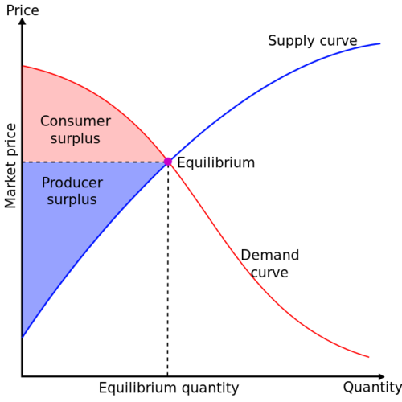
What’s the ideal price for a new piece of technology? Why is a new smartphone model so expensive when it first hits the market, and so much less expensive right before a new model comes out? Intuition may tell you that the more someone wants something, the more they’re willing to pay for it. Intuition isn’t good enough for economists. They want to know exactly how supply, demand, and price interact, and why systems change over time.

Early Adopters and Late Cheapskates
So why do phone prices change so dramatically? It has to do with the difference between the supply curve and the demand curve. The two curves meet at an equilibrium point. When a system is at equilibrium, the price of a new phone is simultaneously the highest a consumer is willing to pay at that point in time and the lowest that the manufacturer is willing to sell the phone for at that time. When a system is in equilibrium, nothing changes. So, for instance, you can buy an outdated flip phone for about $15, even without a contract. These phones aren’t going to get any cheaper, but they’re so inexpensive that most people looking for a flip phone will happily pay the sticker price.
To the right of the equilibrium point, you have a system where sellers aren’t willing to reduce prices to the amount that buyers are willing to pay. In these cases, the seller gets stuck holding on to merchandise or loses money on every sale. When a technology becomes totally obsolete, it may end up in this part of the curve. For instance, no one is interested in buying slide rules anymore except as antiques. So someone manufacturing slide rules would find that there was no way to make a profit off of them.
For economists, and bargain hunters, the most interesting place on the graph is the area to the left of equilibrium. This is where prices fluctuate, where supply can’t always keep up with the demand, and where consumers enter into bidding wars. This is the part of the curve where new smartphones enter the market. The area between the curves to the left of the equilibrium point is called the “surplus.” More surplus means a healthier economy, because consumers are paying less than the most they’re willing to pay for an item, and sellers are earning more money than the lowest price they’ll take for an item. Goods move quickly, because sellers have an incentive to make more, and buyers have an incentive to buy more.
When Apple debuts a new iPhone, there’s a surplus. iPhones cost about $200 to manufacture, with the biggest expenses being the screens and batteries. (Labor only accounts for about $10 of the cost of each phone). Apple could sell the phones for under $300 and still make a profit, yet consumers are willing to pay as much as $1000 for a new phone, as long as most of the costs are rolled into their monthly phone bills. Consumers get their phones, Apple gets its money, and everyone is happy, right?
Well, maybe not everyone. It turns out that the labor costs for an iPhone are so low because the workers who make them are treated very poorly. Social activists have been working to raise awareness about the plight of the Chinese factory workers who assembled your phone. The question is this: are consumers willing to pay slightly more so that manufacturers will treat their employees well?

See for Yourself
- http://www.cbsnews.com/news/the-dark-side-of-shiny-apple-products/ (10 min video)

Student Activity

In groups of two write a page response to this information.

Structure:

Introduction (one paragraph)

3 paragraphs to make up the body:

1 – how producers determine the price for their products and why technology usually starts out at a higher price even though inflation (the constant rising of prices over time) would suggest that the opposite would happen (the price of items rise as time goes on).

2 – Equilibrium price, when would a shortage happen? when would a surplus happen?, what would sellers do to try to get back to equilibrium price (ex. If they are in a surplus they could _____________ to get back to the equilibrium. If they are in a shortage situation they could _____________ to get back to the equilibrium)?

3 – your choice)

Conclusion (one paragraph)

Rubric: Name:____________________________________
5 | 4 | 3 | 2 | 1
All components included:  1 Introduction  2 Price determination of products, why technology starts out at a high price even though inflation (the constant rising of prices over time) would suggest that the opposite would happen (the price of items rise as time goes on  3 Equilibrium price, when would a shortage/surplus happen? What would sellers do to try to get back to equilibrium price (ex. If they are in a surplus they could _____________ to get back to the equilibrium. If they are in a shortage situation they could _____________ to get back to the equilibrium)?  4 your choice  5 Conclusion  Essay is easy to follow and all information is correct | Most components are included and all information is correct | Some components are included and most of the information is correct | A few of the components are included and some of the information is correct | An attempt was made

iPhone Essay Rubric: Name:____________________________________
5 | 4 | 3 | 2 | 1
1 Introduction  2 Price determination of products, why technology starts out at a high price even though inflation (the constant rising of prices over time) would suggest that the opposite would happen (the price of items rise as time goes on  3 Equilibrium price, when would a shortage/surplus happen? What would sellers do to try to get back to equilibrium price (ex. If they are in a surplus they could _____________ to get back to the equilibrium. If they are in a shortage situation they could _____________ to get back to the equilibrium)?  4 your choice and 5 Conclusion  Essay is easy to follow and all information is correct | Most components are included and all information is correct | Some components are included and most of the information is correct | A few of the components are included and some of the information is correct | An attempt was made

iPhone Essay Rubric: Name:____________________________________
5 | 4 | 3 | 2 | 1
1 Introduction  2 Price determination of products, why technology starts out at a high price even though inflation (the constant rising of prices over time) would suggest that the opposite would happen (the price of items rise as time goes on  3 Equilibrium price, when would a shortage/surplus happen? What would sellers do to try to get back to equilibrium price (ex. If they are in a surplus they could _____________ to get back to the equilibrium. If they are in a shortage situation they could _____________ to get back to the equilibrium)?  4 your choice and 5 Conclusion  Essay is easy to follow and all information is correct | Most components are included and all information is correct | Some components are included and most of the information is correct | A few of the components are included and some of the information is correct | An attempt was made

iPhone Essay Rubric: Name:____________________________________
5 | 4 | 3 | 2 | 1
1 Introduction  2 Price determination of products, why technology starts out at a high price even though inflation (the constant rising of prices over time) would suggest that the opposite would happen (the price of items rise as time goes on  3 Equilibrium price, when would a shortage/surplus happen? What would sellers do to try to get back to equilibrium price (ex. If they are in a surplus they could _____________ to get back to the equilibrium. If they are in a shortage situation they could _____________ to get back to the equilibrium)?  4 your choice and 5 Conclusion  Essay is easy to follow and all information is correct | Most components are included and all information is correct | Some components are included and most of the information is correct | A few of the components are included and some of the information is correct | An attempt was made

iPhone Essay Rubric: Name:____________________________________
5 | 4 | 3 | 2 | 1
1 Introduction  2 Price determination of products, why technology starts out at a high price even though inflation (the constant rising of prices over time) would suggest that the opposite would happen (the price of items rise as time goes on  3 Equilibrium price, when would a shortage/surplus happen? What would sellers do to try to get back to equilibrium price (ex. If they are in a surplus they could _____________ to get back to the equilibrium. If they are in a shortage situation they could _____________ to get back to the equilibrium)?  4 your choice and 5 Conclusion  Essay is easy to follow and all information is correct | Most components are included and all information is correct | Some components are included and most of the information is correct | A few of the components are included and some of the information is correct | An attempt was made

