Accounting 11 Unit 1 Test Review
Know how to create an income statement and classified balance sheet from a worksheet.
Know how to complete a worksheet.
Know how to record entries into a journal
Know how to post entries from a journal to a ledger
Know all GAAP’s we have covered so far and be able to explain them
Know all definitions of terms covered in class (example those on your quizzes)

Example Questions for Unit 1 Test:
- Prepare an income statement and a classified balance sheet for the month of October for P. Simpson, Accountant, from the completed work sheet that follows.
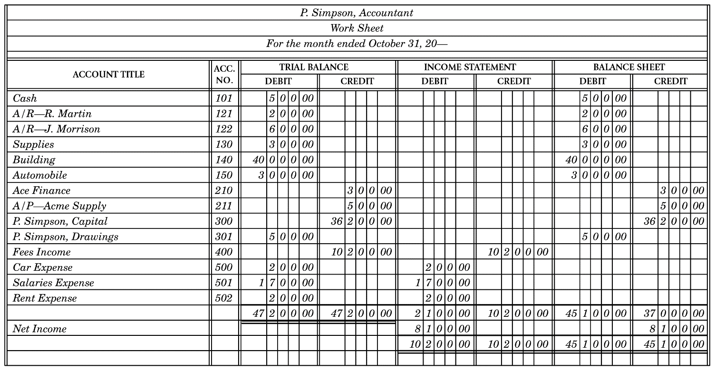
2. Complete the work sheet for P. Simpson, Accountant, that follows.
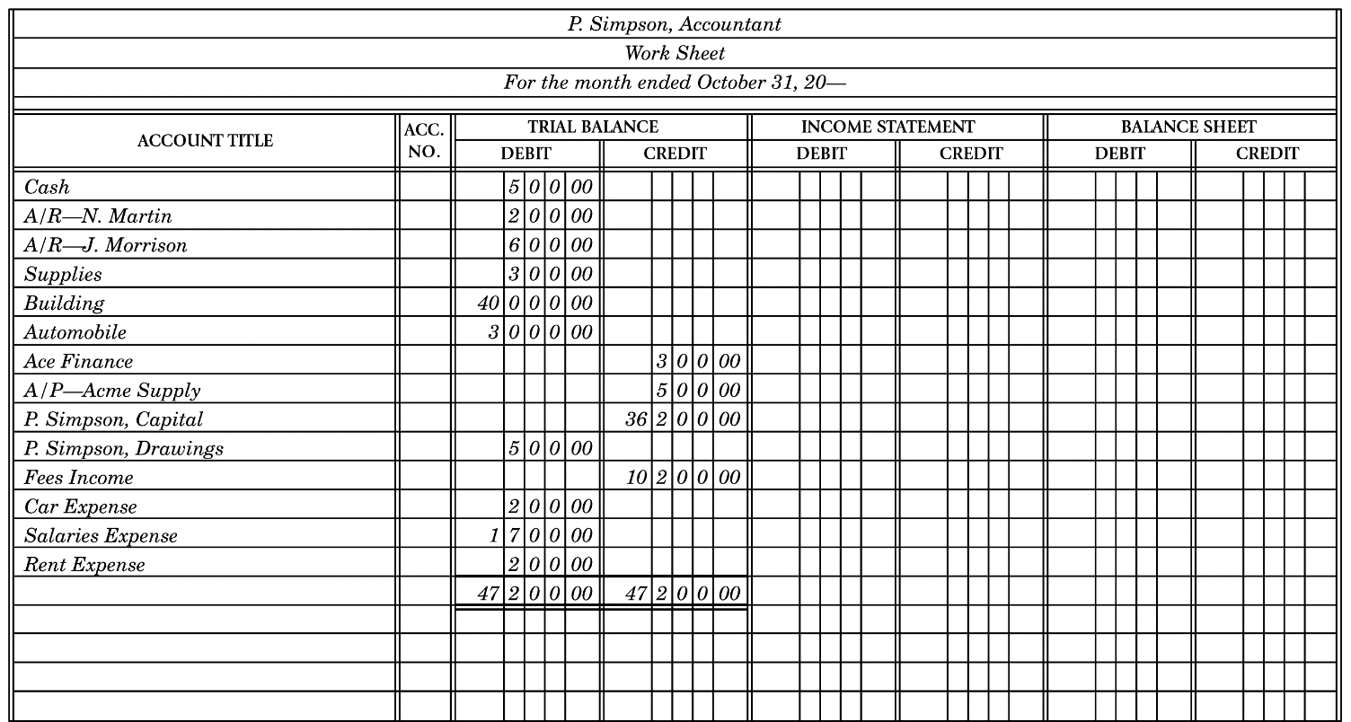

- Record the following transactions on page 3 of a journal.
May 1 Cash sales $200.
2 Purchased office supplies on credit from Willson’s Ltd., $170.
3 A. Burns, the company owner, invested an additional $8000 in the business.
4 Borrowed $11 000 from the bank.
5 Paid $300 cash to The Herald for newspaper advertising.
6 Sold goods on account to L. Auger $800.
9 Paid $90 cash to Willson’s Ltd. on account.
9 Paid $1200 in salaries by cheque.
14 Purchased $900 worth of equipment from Western Supply. Made a $200 down payment. The balance is to be paid in 30 days.
15 The owner, A. Burns, withdrew $500 cash for personal use.
19 Made a $50 donation to the United Appeal (Miscellaneous Expense).
20 Paid $120 cash for the month’s water bill (Utilities Expense).
25 The owner, A. Burns, took a box of computer paper worth $45 from the business for personal use.
31 Paid $700 on the bank loan.

4. Using the completed journal page that follows, head up the accounts required in the ledger and post the transactions.
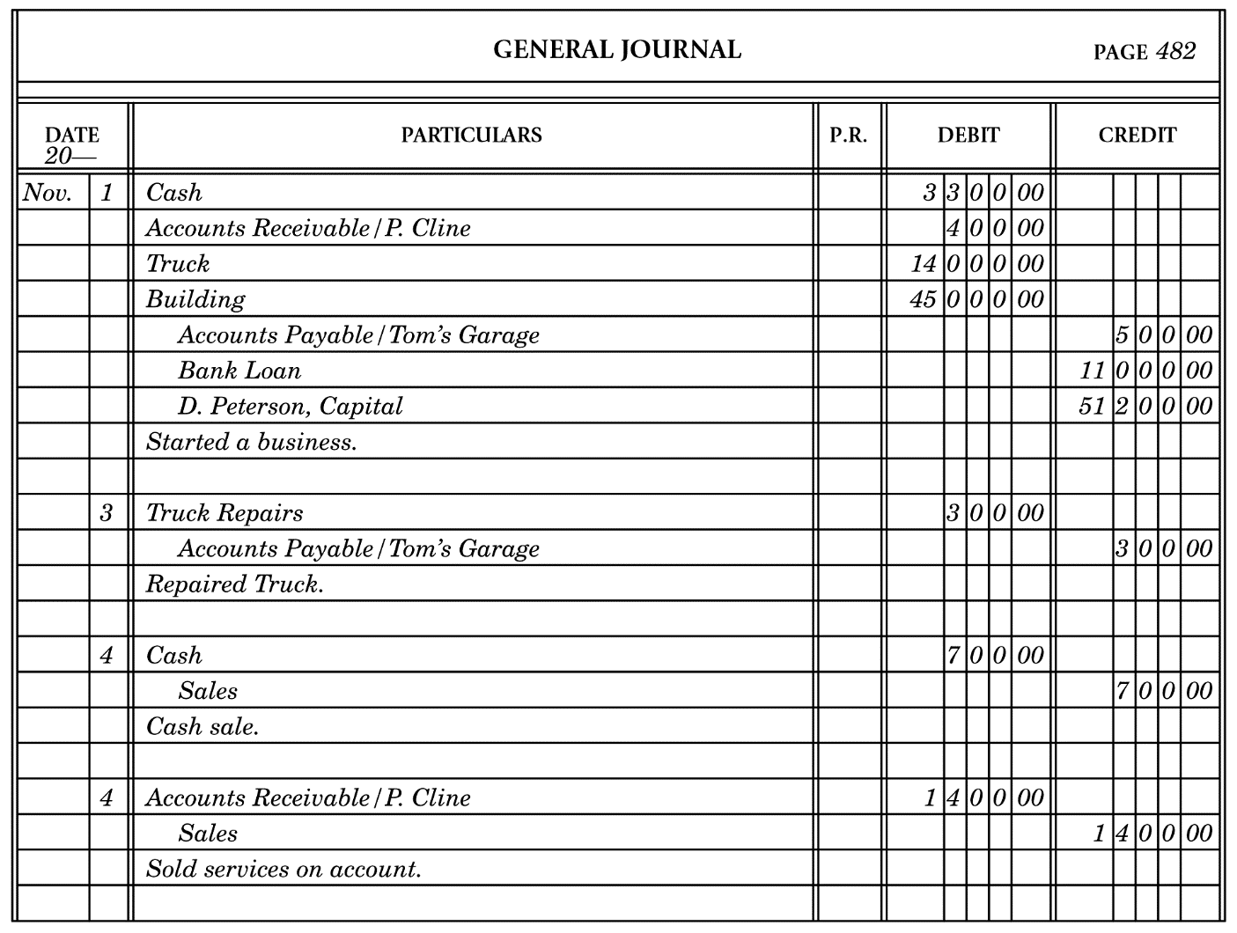
Answers
1.
P. Simpson, Accountant
Income Statement
For the month ended October 31, 20—
Revenue
Fees Income $10 200
Expenses
Car $ 200
Salaries 1 700
Rent 200 2 100
Net Income $ 8 100

P. Simpson
Balance Sheet
October 31, 20—
Assets
Current Assets
Cash $ 500
Accounts Receivable/R. Martin 200
Accounts Receivable/J. Morrison 600
Supplies 300
Total Current Assets $ 1 600
Fixed Assets
Building 40 000
Automobile 3 000
Total Fixed Assets 43 000
Total Assets $44 600
Liabilities and Owner’s Equity
Current Liabilities
Ace Finance $ 300
Accounts Payable/Acme Supply 500
Total Current Liabilities $ 800
Owner’s Equity
P. Simpson, Capital October 1 36 200
Add: Net Income for October $8 100
Less: P. Simpson, Drawings 500
Increase in Capital 7 600
P. Simpson, Capital October 31 43 800
Total Liabilities and Owner’s Equity $44 600

2.
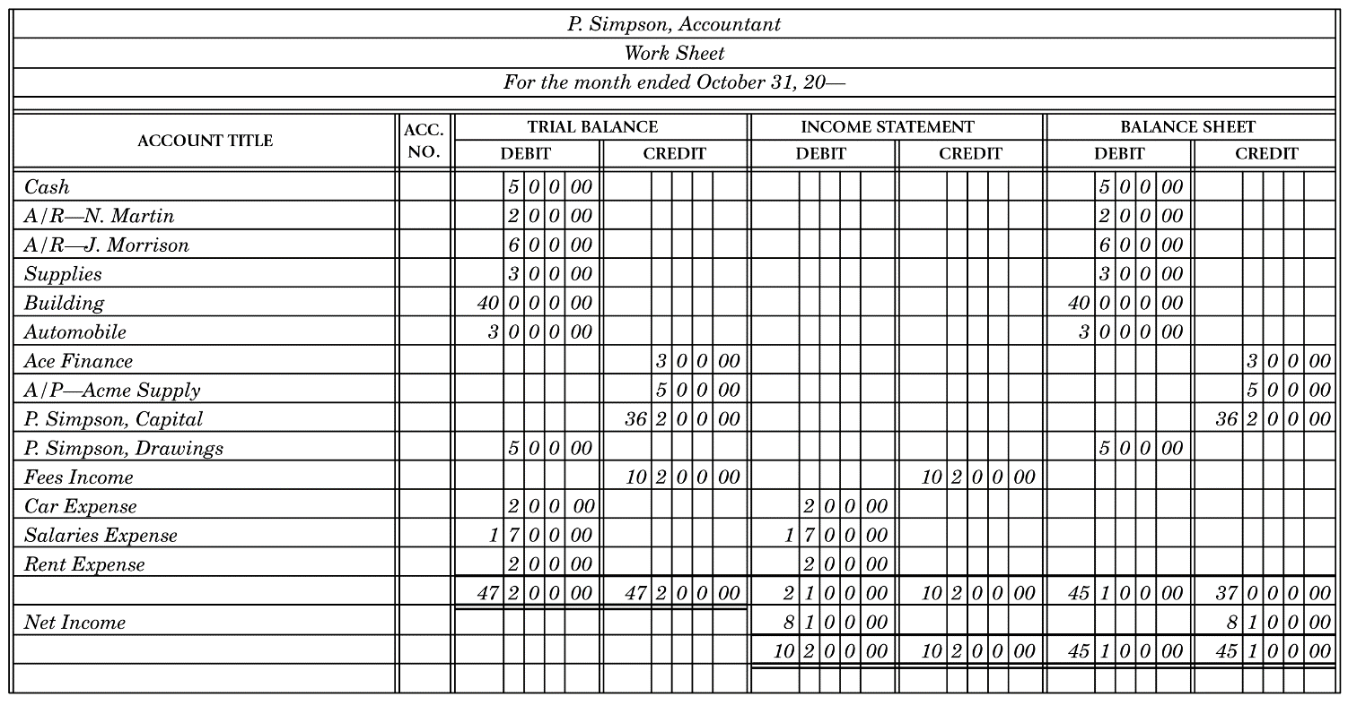
3.
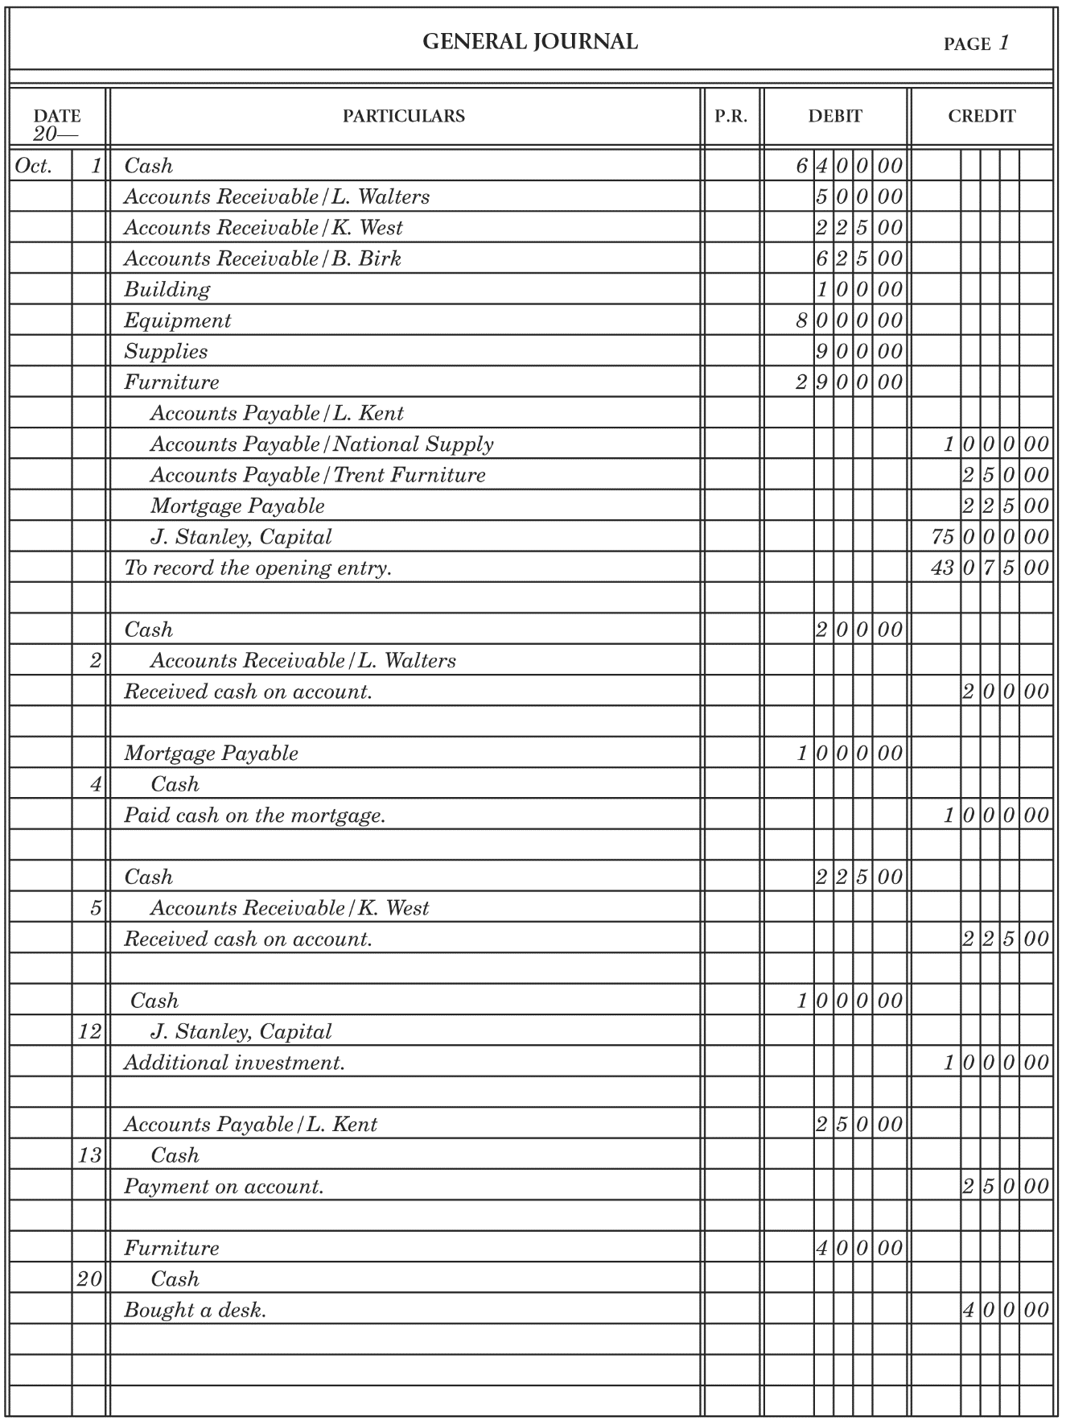

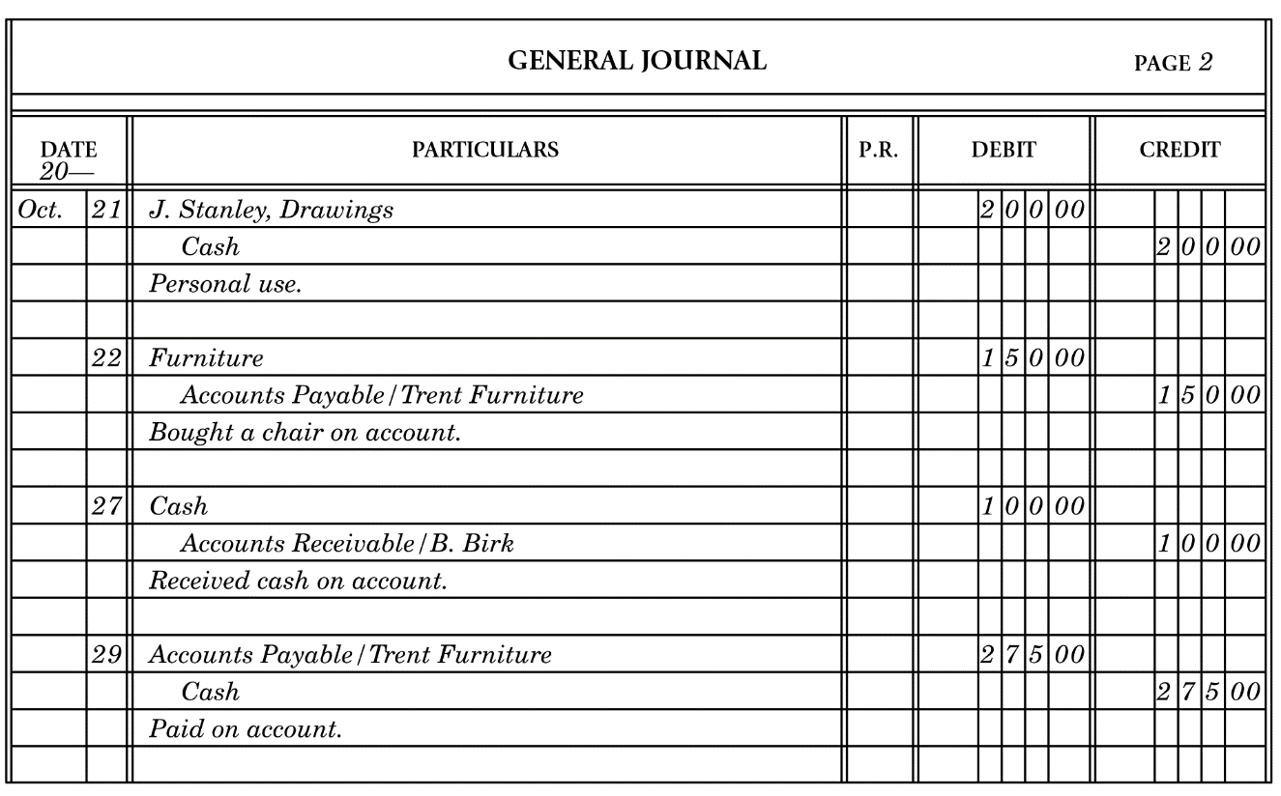

4.

